USER INTERFACE AND DESIGN

EXPERIMENT-1

ROLL NO:240701007 NAME: ABINASH

COMAPARSION OF UI DESIGN BETWEEN TWO FIGMA CREATION

BAD WEBSITE:

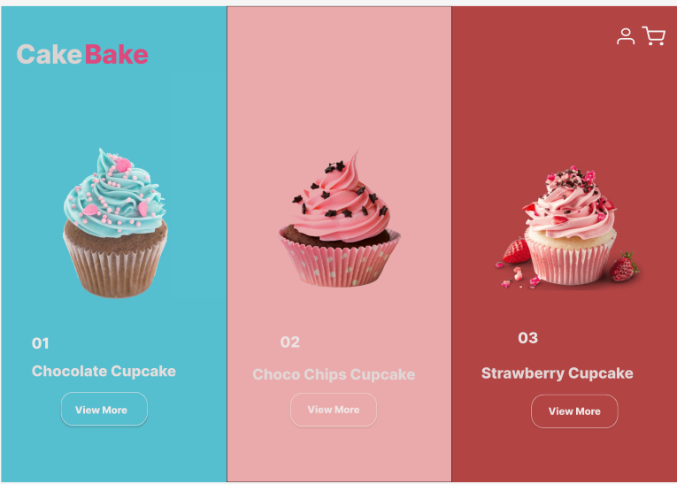

GOOD WEBSITE:

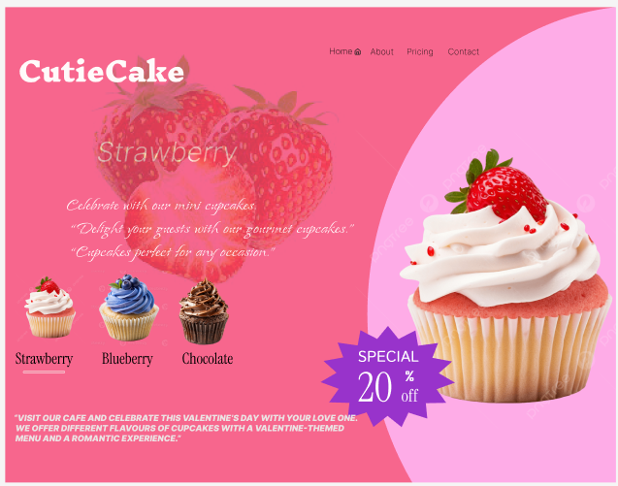

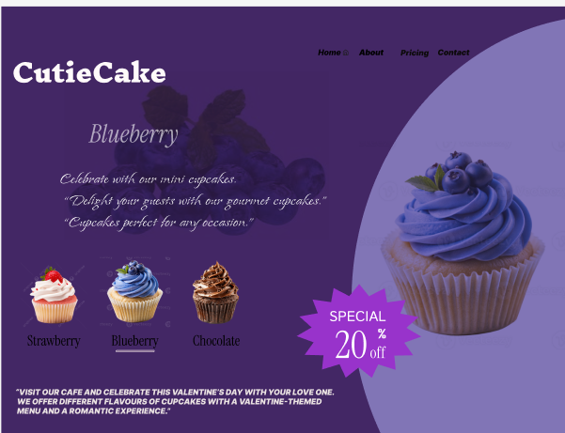
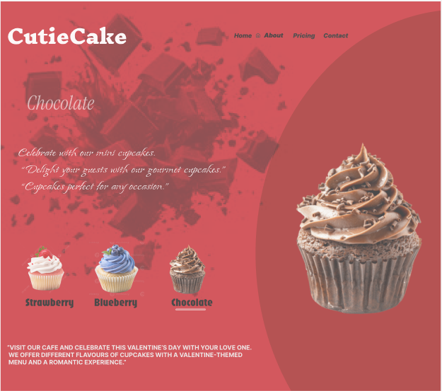

PROTOTYPE LINK:
https://www.figma.com/proto/kNcbA3Pz3S6DH8bpf9NumR/Cake?node-id=23-236&t=E663ERYhQS4FtxhB-1
The two websites have distinct designs and approaches. Here's a comparison:
BAD WEBSITE (CakeBake)
Design Style:
o Minimalistic and clean layout.
o Focuses mainly on product visuals rather than usability.
o Uses strong contrasting background colors (blue, light pink, dark red) that feel visually heavy.
Content:
o Shows three cupcake products with images, numbering, and names.
o Very limited information provided for each product.
o Repetitive “View More” buttons without clear differentiation.
Navigation:
o Very minimal navigation with only user and cart icons.
o Lacks clear menu options or category navigation.
Purpose:
o Appears to be a basic product showcase page for a cupcake or bakery website.

GOOD WEBSITE (CutieCake)
- Design Style:
o Attractive and visually rich design with themed layouts.
o Each page represents a specific cupcake flavor (Strawberry, Blueberry, Chocolate) using matching colors and background graphics.
o Soft, playful, and festive appearance that enhances visual appeal.
- Content:
o Displays cupcake flavors with supporting images and short descriptive text.
o Emphasizes celebration, gifting, and special occasions like Valentine’s Day.
o Clearly highlights a “Special 20% Off” promotional offer.
- Navigation:
o Includes a clear top navigation menu with Home, About, Pricing, and Contact links.
- Purpose:
o Designed to strengthen branding and provide an engaging, enjoyable browsing experience for a bakery or café website

Key Differences:
- Focus: The first website is product-centric, while the second emphasizes storytelling and branding.
- Design Aesthetics: The first is simple and functional; the second is thematic and visually rich.
- Content Depth: The second provides more detail and promotional content, whereas the first focuses on simplicity.
- Target Audience: The first seems tailored for online shopping; the second is for building brand connection and promoting offers.

